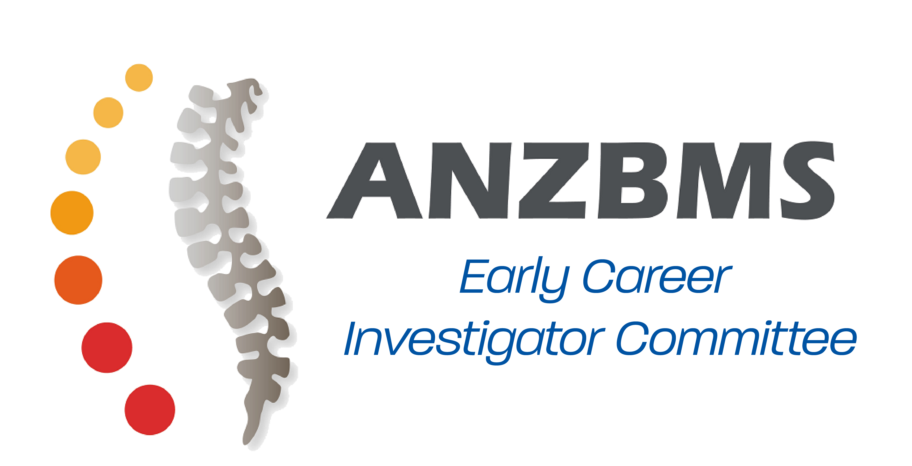

Early Career Investigator Committee Report

Mission

The mission of the Early Career Investigator Committee (ECIC), formed in February 2017, is to help shape the future of bone and mineral research in Australia and New Zealand by fostering active engagement of early career investigators within the Australia & New Zealand Bone and Mineral Society (ANZBMS), supporting professional development of early career investigators and facilitating interactions between junior and senior members of all disciplines.

Objectives

- To act in collaboration with the ANZBMS senior committee and foster active engagement of early career investigators within the ANZBMS.
- To promote activities that engage early career investigators and senior members in open dialogue and collaborative initiatives.
- To increase early career investigator awareness of research trends and application of new technologies in bone and mineral research.
- To increase engagement of clinical trainees and improve training in bone and mineral metabolism.
- Involvement in scientific and social programs at the ANZBMS Annual Scientific Meeting.
- To foster science communication and engagement with the public.
- To facilitate translation of scientific findings to industry and government.

Definition of an Early Career Investigator

Current higher degree or current researcher within 10 years from the award of a PhD/MD.

2017 ECIC Committee

Co-Chairs

Joshua Lewis and Sabashini Ramchand

Members
Alexander Rodriguez  Athena Brunt  Ashika Chhana  Audrey Chan | Christina Vrahnas  Feitong Wu  Jasna Aleksova  Renee Ormsby

Committee Structure

Committee Structure

The ECIC committee will consist of 2 Co-Chairs and 8 members.

Duration of term

24 months.

Half of the inaugural council will remain for a duration of 32 months to prevent all members leaving at the same time. This half will consist of one member from each representation (Career Development, Clinical Training, Communications, and Events).

Duration of term – special considerations
In the event that an ECIC member is unable to complete their 24-month term, the ANZBMS council and ECIC Co-Chairs will nominate a new ECIC member from the pool of ECI applicants who applied for the current term but were unsuccessful at the time.

Application to become an ECIC Member
- Meet the definition of an Early Career Investigator
- Current membership of the ANZBMS for at least 12 months
- Application letter and CV
- Nomination from 2 current members of the ANZBMS. The nomination process involves names and signatures (on the application form) from 2 current members of the ANZBMS who endorse the applicant.

Previous members of the ECIC committee will be permitted to re-apply for a position on the committee but they are not guaranteed a position automatically and will need to go through the same review and selection process as all other applicants. The maximum period of office on the ECIC is two (2) terms. After this period, members will no longer be eligible to re-apply for any position on the committee.

All ECIC committee members will be elected by the ANZBMS council and the ECIC Co-Chairs.

ECIC members, once appointed will be able to nominate to be a career, clinical, communications, or events representative. Where there are more than two (2) nominees for a particular representation (career development/clinical training/events) or more than four (4) nominees for the communications representation, the ECIC will decide by majority vote.

At the time of applying to become a member of the ECIC, applicants will be given the opportunity to indicate whether they wish to be considered for the position of ‘Co-Chair’.

Roles and Responsibilities of Committee Members

All committee members should be actively involved in brainstorming new ideas, developing future programs, providing regular feedback and updates on responsibilities, and evaluating past programs of the ECIC.

Career Development Representatives (2)
- Plan and head ECIC initiatives aimed at career development of early career investigators.
- In collaboration with the Communications Representatives, formulate regular emails for the ECI mailing list advertising ECIC initiatives and events.
- In collaboration with the Communications Representatives, disseminate information on relevant grants, scholarships and awards aimed at ECIs.

Clinical Training Representatives (2)
- Liaise with the Endocrinology Specialist Advisory Committee (SAC) and ANZBMS Representative.
- Plan and head ECIC initiatives aimed at increasing engagement of clinical trainees and improving training in bone and mineral metabolism.

Communications Representatives (4)
- Responsible for drafting minutes of meetings and any communications of the ECIC committee.
- Drafting of the Annual ECIC Report from the Annual ECIC Meeting.
- Liaise with the Career Development Representatives to formulate regular ECI specific emails.
- Liaise with the ANZBMS Communications Committee to manage the ANZBMS website and other forms of social media used by ECIC.

Events Representative (2)
- Plan and oversee ECIC initiatives at the ANZBMS ASM
- Plan and oversee other ECIC Events
- One representative will also serve as a member of the ANZBMS Program Organising Committee.

2017 Representatives
Career Development Representatives Feitong Wu and Alexander Rodriguez
Clinical Training Representatives Jasna Aleksova and Sabashini Ramchand
Communications Representatives Athena Brunt, Renee Ormsby, Christina Vrahnas and Joshua Lewis
Events Representatives Audrey Chan and Ashika Chhana

